MAKERERE UNIVERSITY

COLLEGE OF COMPUTING AND INFORMATION SCIENCES

DEPARTMENT OF NETWORKS

BACHELOR OF SCIENCE IN SOFTWARE ENGINEERING (YEAR 2)

RECESS TERM 2 (BSE 2301)

SYSTEM REQUIREMENTS SPECIFICATION FOR:

STAR WARS MOVIE SCRIPTS ANALYSIS PROJECT

GROUP ONE

PROJECT MEMBERS:

|  |  |  |  |
| --- | --- | --- | --- |
| S/NO. | NAME | REGISTRATION NO. | STUDENT NO. |
| 1 | ONGOM DANIEL | 16/U/18975 | 216020552 |
| 2 | NABWIRE BABRA KILO | 16/U/8255/PS | 216012375 |
| 3 | NANYANZI VICTO | 16/U/9914/PS | 216012525 |
| 4 | KABENI EMMANUEL | 16/U/20449 | 216022248 |
| 5 | THAKKAR BRINDA | 16/X/2271/PS | 216002450 |

PROJECT LEADER: ONGOM DANIEL

SUPERVISOR: NOAH KANGE

SUBMITTED IN PARTIAL FULFILLMENT OF THE REQUIREMENTS FOR THE

SOFTWARE ENGINEERING RECESS PROJECT BSE 2301

26th JUNE 2018

**Software Requirements Specification**

**For**

**The Star Wars Movie Script Analysis**

**Version 1.0**

**Prepared by Group One**

**26th June, 2018**

Contents

1 INTRODUCTION 2

1.1 PURPOSE 2

1.2 DOCUMENT CONVENTION 2

1.3 INTENDED AUDIENCE AND READING SUGGESTIONS 2

1.4 PRODUCT SCOPE 2

1.5 REFERENCES 2

2 OVERALL DESCRIPTION 3

2.1 PRODUCT PERSPECTIVE 3

2.2 PRODUCT FUNCTION 3

2.3 USER CLASSES AND CHARACTERISTICS 4

2.4 OPERATING ENVIRONMENT 4

2.5 DESIGN AND IMPLEMENTATION CONSTRAINTS 4

2.6 USER DOCUMENTATION 4

2.7 ASSUMPTIONS AND DEPENDENCIES 4

3 EXTERNAL INTERFACE REQUIREMENTS 5

3.1 USER INTERFACE 5

3.2 HARDWARE INTERFACES 5

3.3 SOFTWARE INTERFACES 5

3.4 COMMUNICATIONS INTERFACES 5

4 SYSTEM FEATURES 6

4.1 SYSTEM FEATURE (Use Case Diagram) 6

4.2 UPLOAD FILE 6

4.3 DATA VISUALIZATION 6

4.4 WRITER’S CHOICE 7

5 OTHER NON-FUNCTIONAL REQUIREMENTS 7

5.1 PERFORMANCE REQUIREMENTS 7

5.2 SAFETY REQUIREMENTS 7

5.3 SECURITY REQUIREMENTS 7

5.4 SOFTWARE QUALITY ATTRIBUTES 7

5.5 BUSINESS RULES 7

5.6 OTHER REQUIREMENTS 7

6 APPENDIX A: GLOSSARY 8

7 APPENDIX B: ANALYSIS MODELS 8

# INTRODUCTION

## PURPOSE

The purpose of this document is to describe into details the requirements specifications and features of the Star Wars movie script analysis project, version 1.0.

## DOCUMENT CONVENTION

This includes the standards and typographical conventions that are used in this software requirements specification document. These include; Font style as Times New Roman, Font size of 12, Line spacing of 1.5, Project name, keywords plus titles are bold for emphasis. Section headings are numbered as 1, 2, 3, and subsection headings as 1.1, 1.2, 1.3… accordingly. Diagram labels are italic.

## INTENDED AUDIENCE AND READING SUGGESTIONS

This document is useful to instructors, co-developers, project managers, documentation writers (movie writers), testers and any other person interested in data analysis as explained below.

* The project managers and the developers need to become intimately familiar with this Requirement document.
* The Testers need to be well versed with the system features of the document to develop meaningful test cases and give useful feedback to the developers.
* The stake holder associated with manufacturing hardware need to review the External Interface Requirements, non-functional and Functional Requirements of this document to know the requirement specifications of the needed hardware.

## PRODUCT SCOPE

In this project, we are developing a software model for analysing and visualizing text data of the Star Wars movie script in order to conclude writer’s inference and insinuation of each character. The documentation also includes objectives and benefits of the Star Wars movie script analysis project as specified in the concept paper (refer to concept paper for goals, objectives and benefits). This project will be based on a computer that has an RStudio, a free integrated development environment for R programming language together with the relevant packages.

## REFERENCES

Books: IEEE software requirements specification template

Links: [1]<https://en.wikipedia.org/wiki/Software_requirements_specification>

# OVERALL DESCRIPTION

## PRODUCT PERSPECTIVE

The Star Wars movie script analysis is a new self-contained software model, that is to be developed by a project development team to give the author and other users visual and analytic information about the Star Wars movie.

## PRODUCT FUNCTION

*CONTEXT DIAGRAM FOR STAR WARS MOVIE SCRIPTS ANALYSIS*

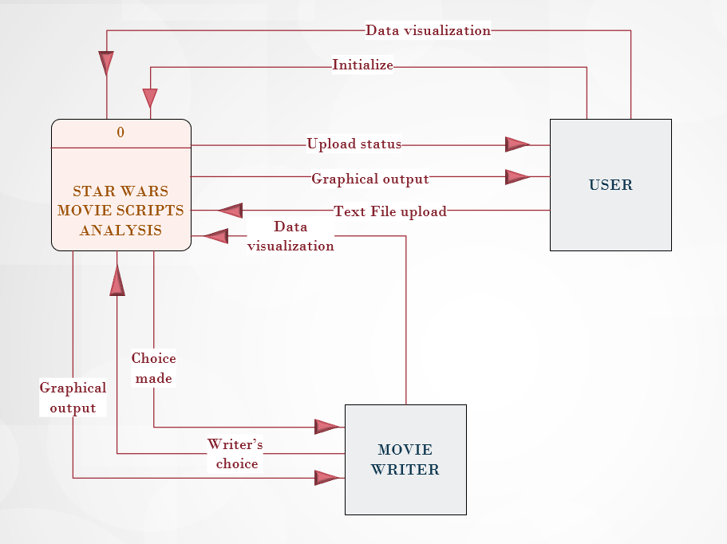

*Figure 2.2.1 System Context Diagram*

As illustrated in *Figure 2.2.1* above, the user initializes the system and uploads script files into the Star Wars movie script Analysis system. The system then performs text analytics on the scripts after which the resulting that can then be visualized and analysed by the user depending on their choice as well as the class of the user. The user of a particular class will then be able to decide and make conclusions according to his/her findings on the results displayed.

## USER CLASSES AND CHARACTERISTICS

This software is to be used by different user classes including movie writers and other users that may include data administrators as well as data analysts. Movie writers are expected to have read the user manuals for them to be able to use the system. The data administrator is expected to have an IT field appropriate diploma or equivalent certificate and experience of at least a year as an administrator. He or she has full access to the data stores for maintenance and update. On the other hand, the data analyst should have a field appropriate degree and experience two years in an IT as a data analyst so as to have full access to the data stores and the system interfaces in order to analyse data.

## OPERATING ENVIRONMENT

The system will operate effectively on all modern computing environment (for example a computer whose RAM is at least 2.0 GB with an average processing speed of at least 2.0 GH). The computer should have Linux operating system 12.04 and above, or windows operating systems 7 and above on which R and RStudio have been installed.

## DESIGN AND IMPLEMENTATION CONSTRAINTS

The system is constrained by a number of factors as highlighted below: -

* Hardware Constraints: The system will be able to run on a machine having a minimum configuration of 2GB RAM, 2 Cores (1.86 GHz) CPU, 250 GB hard disk, and configuration for better performance is in the range of 2GB – 4GB RAM.
* Time constraint: The system must be delivered late July, 2018
* Technology Constraints: The data analysis and visualization tools such as the R language and it will not have a database.
* Language requirement: The system will strictly use English as its standard language
* Programming standards: The system software will be maintained by the development team

## USER DOCUMENTATION

The system will be delivered with more documents including the ones mentioned below:

* System User Manual (PDF document)
* System tutorials (PDF document)

## ASSUMPTIONS AND DEPENDENCIES

The system is developed in R using RStudio and therefore requires R to be installed on the user’s computer. The user must have all the required R packages for the system to run. It requires the latest R version 3.5.0 or higher, and this applies to both windows and Linux users.

# EXTERNAL INTERFACE REQUIREMENTS

## USER INTERFACE

*STAR WARS MOVIE SCRIPT ANALYSIS SYSTEM USER INTERFACE*



*Figure 3.1.1 System Context Diagram*

As shown in *Figure 3.1.1*, when a user accesses the Star Wars movie script analysis system, he/ she uploads the file scripts to the system, he can then choose from the buttons on which output he expects from the system.

## HARDWARE INTERFACES

The hardware interfacing with the system is basically the modern computer hardware component with the minimum hardware requirements of the system are 2GB RAM, 2 Cores (1.86 GHz) CPU, 250 GB Hard Disk and configuration for better performance is in the range of 2GB – 4GB RAM. A compatible graphics card is required for efficient visualization.

## SOFTWARE INTERFACES

The system requires software like a browser (latest browsers such Mozilla Firefox, Chrome, Explorer as well as Safari) that will be used to enhance the use of the system, since the system is built based on Shiny applications technology. Additional information can be found on section 2.7 of this document.

## COMMUNICATIONS INTERFACES

The system requires protocols such as Hypertext Transfer Protocol (HTTP) and File Transfer Protocol (FTP) for file transfer. Once the system is hosted then, an internet connection shall then be required for the user to have access to the system.

# SYSTEM FEATURES

## SYSTEM FEATURE (Use Case Diagram)

*USECASE DIAGRAM FOR STAR WARS MOVIE SCRIPTS ANALYSIS*

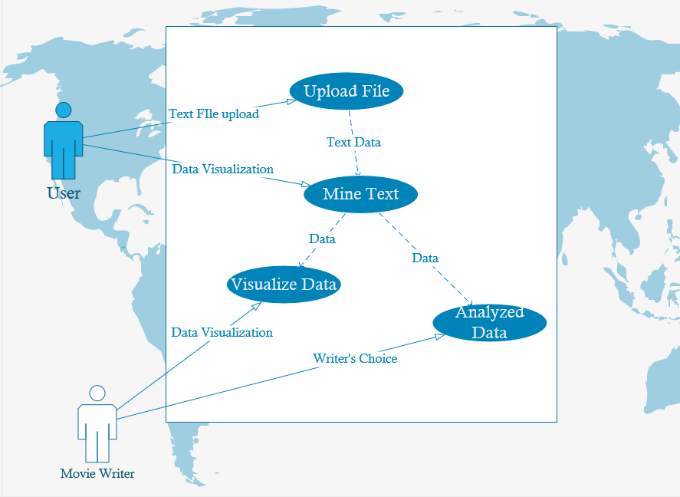

*Figure 4.1.1 System Context Diagram*

## UPLOAD FILE

The user will initialize the system and thereafter, he or she will select the file to be analysed and will upload it by clicking the upload button. Once uploaded, the file will be verified in the verification model and the passed to the text analytics model where the text data is analysed and visualized by system users.

## DATA VISUALIZATION

For clear representation, both the user and movie writer will need to visualize the data graphically using the visualization tool of desired choice. Visualization tools will be specified by the users, this will include among others word cloud, bar plots, histogram and others. The graphical output will then be displayed on the user’s monitor.

## WRITER’S CHOICE

The movie writer will choice the file to be visualized and analysed. In this case, we assume that the files had been uploaded into the system by the user and its available to other entities, for instance movie writers.

# OTHER NON-FUNCTIONAL REQUIREMENTS

## PERFORMANCE REQUIREMENTS

Performance depends on the RAM size and the number of CPU cores of the computing system. For instance, a system of 2GB RAM and above, 2 CPU Cores (1.86 GHz) and above.

## SAFETY REQUIREMENTS

The system employs techniques that are pertinent to data integrity. Data in this case is text and the format that it’s read into the system (textual) is maintained and processed as the user instructed.

## SECURITY REQUIREMENTS

Access to the system will be open to every user who is able to use a computer system, basic computer literacy is an added advantage.

## SOFTWARE QUALITY ATTRIBUTES

The system is easy to use and it has graphical user interfaces that eases user’s interaction with the system.

## BUSINESS RULES

All system users have equal permissions to use all the system functionalities, thus they can perform all kinds of functions under all circumstances.

## OTHER REQUIREMENTS

Currently all the system’s functional and non-functional requirements are specified in the documentation. As the user’s taste and preferences changes thus, it will be added in the next version of the documentation.

# APPENDIX A: GLOSSARY

Reference: https://economictimes.indiatime.com

Debugging is the process of detecting and removing of existing and potential errors (bugs) in a software code that can cause it to behave unexpectedly or crash.

Visualization is the representation of an object, situation or a set of information as a chart or other image.

Data analysis is a process of inspecting, cleaning, transforming and modelling data with the goal of discovering useful information and support decision making.

Data store is a repository for persistently storing and managing collections of data which include repositories like databases.

# APPENDIX B: ANALYSIS MODELS

Data Flow Diagram (DFD) is a unified modelling tool which shows how the system stores, processes, and transforms data.

A Use Case Diagram visually represents the interaction between users and the information

System. In a use case diagram, the user becomes an **actor**, with a specific role that describes how he or she interacts with the system.